Testing of LEDL board.

2/10/18

Q26 Pin 3 was not connected to R1 Pin 1 to connect power path from battery to system. I soldered a wire to connect the two pins.

Checked to see that LEDL VCC was not shorted to ground. Checked both rails. The CDH rail H2 Pin 28 and Pin 30, and all LEDL Power capacitors.

Created a jumper wire to connect to UART to LEDL board. Successfully checked that I could connect to a CP2102 board.

LEDL can be connected to crossworks and have a DEV test program downloaded to the MSP.

When connected to CP2102 board LEDL does not transmit characters to tera term. UART pins are connected to P3.5 and P3.6 (TX, RX respectively) on DEV board. LEDL has UART connected to P4.3 and P4.4 (TX, RX respectively).

2/12/18

Looked at the pins, LEDL code is now the same as COMM code to use the UART bridge. I was looking at the schematic and found that the 3.3 V connected to the JFET and the +3.3 V connected to the UART are not actually connected and do not connect to the LEDL board. So the LEDL is not actually powered with the two plugged in. This is probably why it is not responding to the UART.

2/13/18

I fixed the power pins from the UART and the JFET and connected them to the 3.3 V rail that LEDL is connected to for it’s voltage regulator. NOTE: Pins need to be fixed on schematic. Looking at the UART in debugger it seems that the msp is getting the char in on the RXbuf, and is outputting the char on the RX buff. This means that the connection may not be good going into the device. I found the connection, the RX pin on the UART connector on the LEDL board was not soldered well. I fixed this and now the LEDL can communicate with the tera term.

I have been able to write to the SD card.

3/21/18

Over the weekend Kyle and I were working on the LEDL board and we were finding that when the voltage supplies were turned on the UART was not able to communicate and show characters in the tera term screen. When it would work, there is an under voltage error that pops up. I currently have his code on my LEDL and I am not having that problem. I currently have all 3 voltage rails turned on. I have not been able to communicate with the sensors yet.

3/22/18

Gyro Command works.

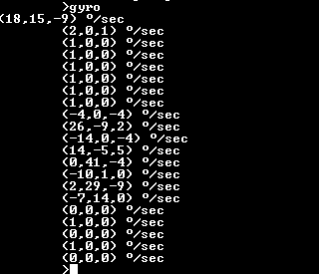

Temperature sensor is working

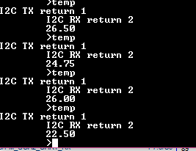

I have found that the PMOS are allowing voltage on the Clyde power rail. As the LEDL power rail goes high, the diode internal to the PMOS conducts current and 2.9 V is measured on the clyde power rail.

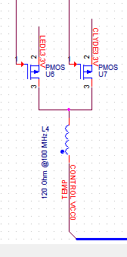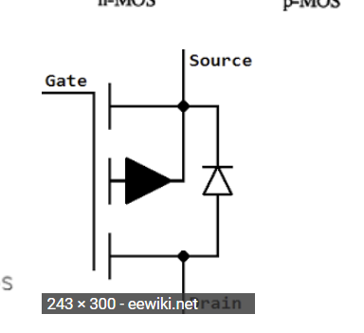

3/22/18

Starting on the project, the LEDL does not seem to connect to crossworks any more. The msp is acting like it won’t operate, the tera term wont connect and the LEDs are not on the PMOS are not held in an off position. The MSP and the internal voltage both measure 3.33 from the vsupply of the tera term/fet connection. I think I need to replace the msp. Nevermind. It now works.

Now I am trying to get the accelerometers working. The acc voltage is only 2.8 V, the input to the PMOS is 0, so the output should be 3.3 V. I think I will try to replace the sensor to see if it works better. Only, the accelerometer U8 PMOS has an input voltage of 2.8 V, while the rest of the LEDL pmos power controls have 3.3 V on the LEDL rail. Is solder joint is bad on Pin 2 of PMSO U8? All appear to be shorted. Fixed. The PMOS was not connected to the voltage rail. Soldered Pin and now ACC V rail is 3.3 V.

Now working on accelerometer, this is the first time it has been used. Never tested before so the code is not verified. I am working on looking through the code to check that it works. When you use it currently, the code returns a -1 on the first transmit to the Accel. The first address it sends is 0x18, which is what is coded to it. The device does not ack, so the error is a NACK. I thought to look at the device how it is wired look to next figure. We did not connect to wire to anything. The data sheet says that if you do not connect the wire it is pulled up internally.



Page 9 of data sheeet, footnote to Table 2: Pin decriptions

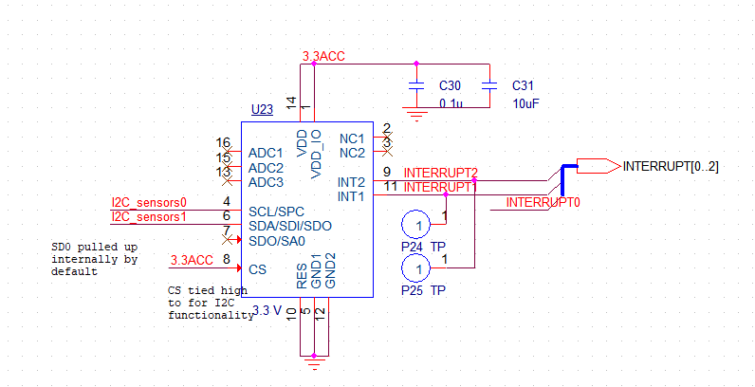

The slave address is addressed based on the data sheet. If SDO is connected to ground that this 0011000, if it is connected to VCC than this address is used 0011001. Since we are connected internally to Vcc our address for the device is 0011001.

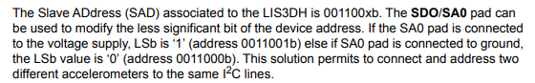

0011001b -> 0x19. Based on this, I am going to change the code to be 0x19.

I was not having any success connecting with the accelerometer so I tried adding solder to the pins to see if it would help. As I was trying to connect to the uart, my 5 pin connector snapped off my board. To remedy this, I soldered wires to the small pins and soldered the wires to a CP2102 box cable for connection. Since I need to order a new board anyway, I figured I would just try to get through testing the last of the components, being the accelerometer.

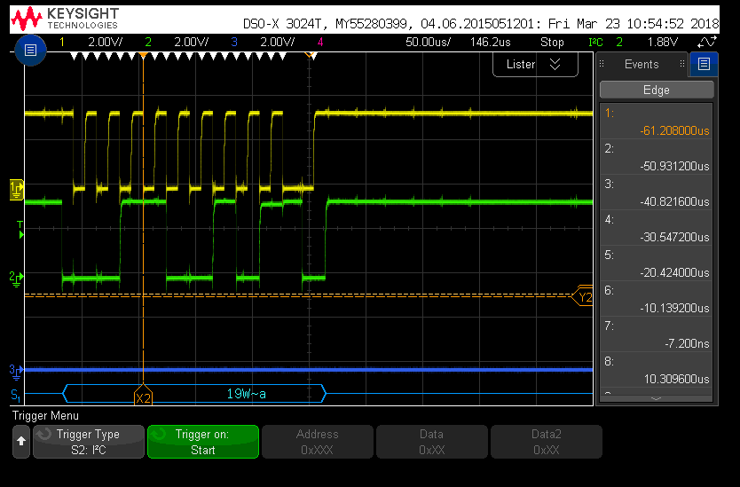

0 0 1 1 0 0 1 0 1

3/23/18

After attemting to resolder the accelerometer I was finally able to get the accelerometer to work with the I2C protocol. This is the current data from the device.

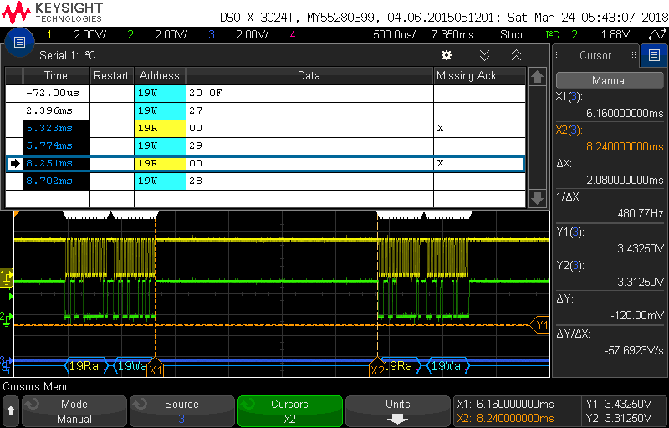

The device is acknowledge the command for accelerometer data, but it does not ack when reading the register. I looked into the device and came across this following data. 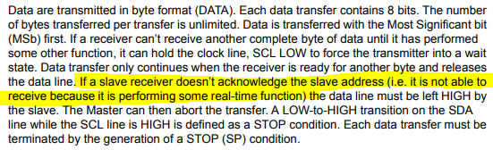

Basically the device may be held up with something and I cannot get the data yet. I am going to look into the time necessary for the accelerometer to take data. Or why this might be happening.

It appears that initially on wake up the device is in a low power mode. The device needs to be set up for data use. So far the following need to be set up.

March 27, 2018

Idea for updated LEDL board. Connect the Clyde VCC to one of the digital I/O on LEDL. Use as a varication method to make sure that the Clyde power is on.

Looking back at the ACC – I am trying to find out how to set it up to take the data rate that I need. I would like to sample at the highest rate of 5376 Hz, this will put the device in a LPM sampeling 8 bit data.

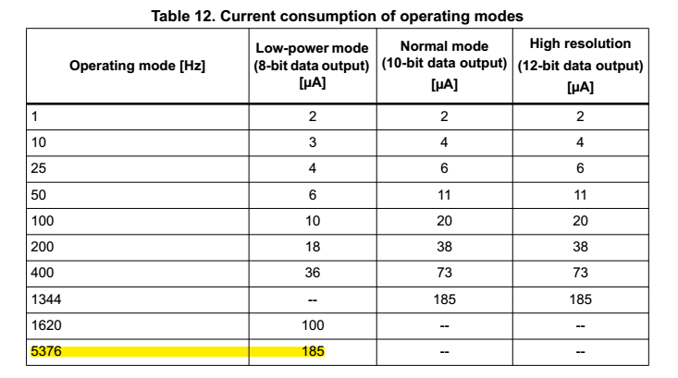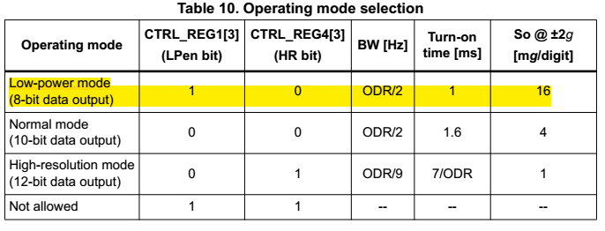

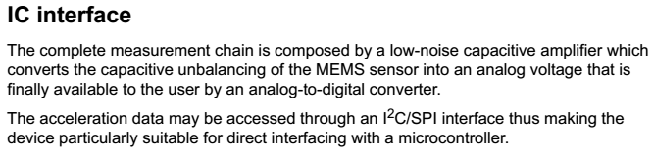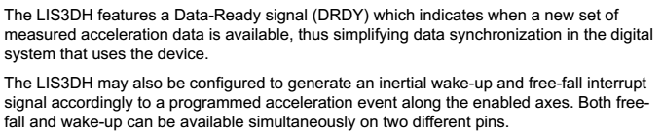

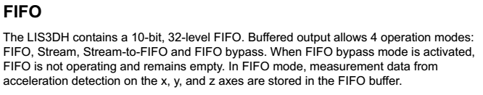

April 3, 2018

The board has not been connecting to the fet programmer. One thing that I have noticed is that the RST pin is measured at 870 mV. The RST works by pulling the pin low. I am wondering if the internal resistance is not pulling up the line. Is the device in a constant reset mode?

I saw that my pulldown resistor was not on the board. It looks like it broke off. So I soldered a new resistor on. It made me think that the fet may have been slightly on, causing the rst pin to be pulled low a little bit. 604 K that I had in my design was too large. Changing it to the 47k made it connect.

Now the msp will not connect with the tera term correctly. I can see that characters are making it to the UART RX of the msp but the MSP is not sending them back out the UART TX. The pin is held high like it is supposed to though.

Carie found why the UART wasn’ working. For some reason when I changed myh code I did not specify what happened when I overran a temp array buffer. By changing it to a unsigned char it keeps the temp array from overflowing.

April 12, 2018

I am still trying to figure out why if I add any code the UART stops working. I found that I am resetting and I am getting the following error codes.

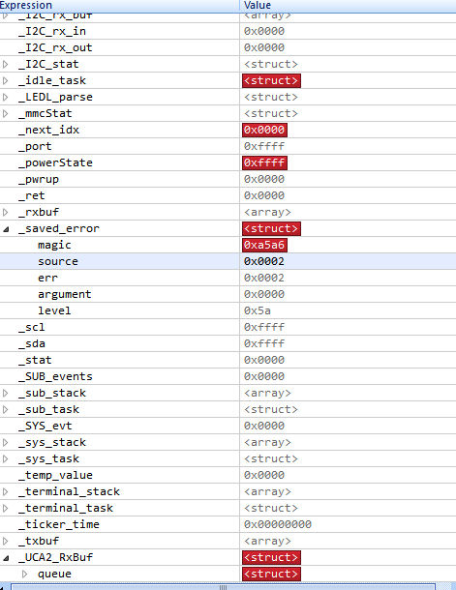

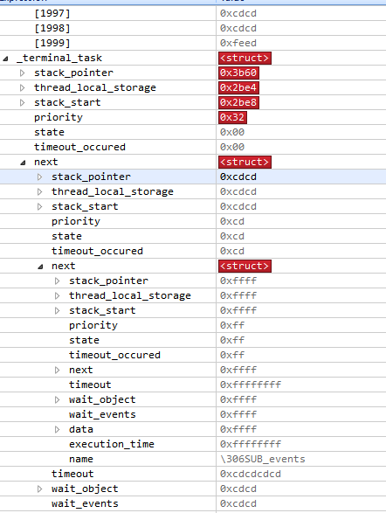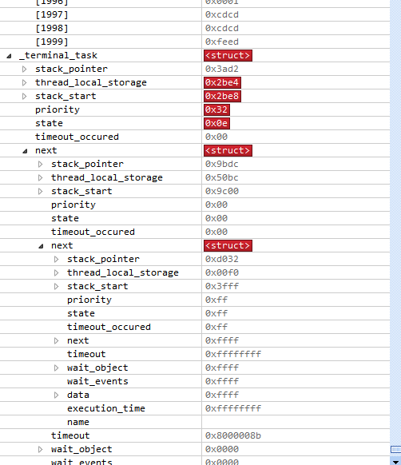

Left side terminal doesn’t work, right side does work. The next stack pointer is pointing at cdcd, predefined values. Its not pointing to the correct thing.